Final Assessment-Alternative Assessment
Semester | 202520 | Division | CIS
Assessment title in Syllabus | Final_Project_Portfolio | Program | Bachelor of Information Technology/ Bachelor of Information Systems
Course Code | CDS 2413
Course Title | INTRODUCTION TO DATA SCIENCE
Course Instructor |  | CRN
Assessment | Project Deliverable 1 – Data Analysis Report | Submission Date | Week 6
Student Declaration:
Academic Integrity Statement
In accordance with the HCT Academic Integrity Policy
• Students are required to refrain from all forms of academic integrity breaches as defined and explained by HCT.
• A student found guilty of having committed acts of academic integrity breach(es) will be subject to the relevant sanctions as outlined by HCT.
إفادة النزاهة الأكاديمية
وفقًا لسياسة كليات التقنية العليا للنزاهة الأكاديمية
• على الطلبة الإلتزام بلوائح وقواعد النزاهة الأكاديمية، كما هو مبيّن وموضح في السياسات والإجراءات الخاصة بكليات التقنية العليا.
• في حالة ارتكاب الطالب أي شكل من أشكال الإخلال بالنزاهة الأكاديمية، سيتعرض الى العقوبات الموضحة في السياسات ذات الصلة.
This assignment is entirely my/our own work except where I have duly acknowledged other sources in the text and listed those sources at the end of the assignment. I have not previously submitted this work to the HCT, or any other entity. I understand that I may be orally examined on my submission.

Student HCT ID(s): | H00502480 | H00502479 | H00566093 | H00
Student Name(s): | Muath Mohammed | Mohammed Faisal Alshehhi | Zayed Alblooshi
Student Signature | Muath | Mohamed | Zayed
Chatbot (e.g. ChatGPT) statement
This submission allows you to use AI generated tools, but the prompt used must be stated and the response must be in red font. Include References to ChatGPT.

Instructions

Remove instructions and hints from the template before submitting the final report to BBLearn.

CLO1: Introduction and Data Wrangling (5 Points)

Purpose of Data Analysis (1 point)

The purpose of this data analysis is to study the factors that affect student academic performance.This analysis aims to understand how variables such as study hours, attendance, parental support, and other factors influence students’ exam scores.
The goal is to identify which factors have the strongest relationship with student performance and help improve academic results.

Type of Programming (1 point)

Python programming is used for data analysis.It is suitable because it provides powerful libraries for data processing and statistical analysis.
Pandas is used for data manipulation, NumPy for numerical operations, Matplotlib and Seaborn for visualization, and SciPy for hypothesis testing.
I chose Python because it is simple, efficient, and widely used in data science.

Type and Purpose of ML algorithm (1 point)

The machine learning algorithm used in this dataset is Linear Regression , which is a supervised learning algorithm.It will be used to predict the dependent variable (GPA) based on independent variables such as StudyTimeWeekly and Absences. The purpose of this algorithm is to understand the relationship between study-related factors and student performance and to predict future academic outcomes.

Identify the Varaibles (1 point)

The dependent variable is:
• GPA (Grade Point Average), which represents the student’s academic performance and is the main outcome we want to analyze and predict.
The independent variables include:
- Study Hours
- Attendance
- Parental Support
- Gender
- Tutoring
- Other academic factors
These variables are independent because they may influence the student’s exam score.

Sampling (1 point)
Yes, sampling will be performed so two types of sampling will be used:
- Random Sampling
A random sample of 150 students will be selected from the dataset.
Random sampling ensures that every student has an equal chance of being selected.
This helps reduce bias and makes the sample representative of the population.
- Systematic Sampling
Systematic sampling will be performed by selecting every fixed interval from the dataset (for example, every 5th row).
This method follows a clear pattern and is simple to apply.
It helps reduce the dataset size while keeping the data organized and representative.
Sampling is used to reduce the dataset size while keeping it representative of the population.

CLO2: Descriptive, Exploratory and Statistical Analysis (10 Points)

Purpose of Descriptive Analysis (1 point)
The purpose of performing descriptive analysis on this dataset is to understand the overall performance of students based on the dependent variable, which is GPA. Descriptive statistics help summarize the data using measures such as mean, median, minimum, maximum, standard deviation, and quartiles. These measures allow us to see the central tendency and the spread of the data. By analyzing the GPA variable, we can identify whether the students’ performance is consistent or widely distributed. Descriptive analysis also helps detect possible outliers and understand the shape of the distribution through skewness. This step is important before applying hypothesis testing or machine learning because it ensures that the data is properly understood and interpreted. Overall, descriptive analysis provides a clear summary of student performance and supports accurate data-driven decision-making.

Script for Descriptive Analysis (1 point)

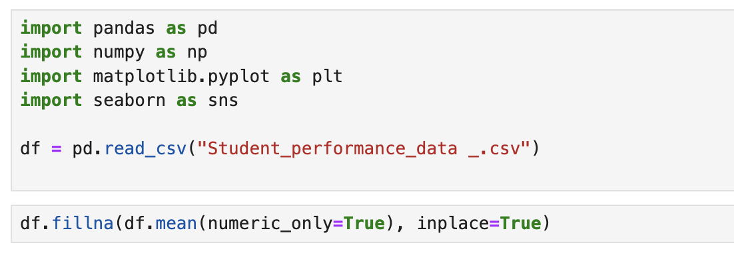

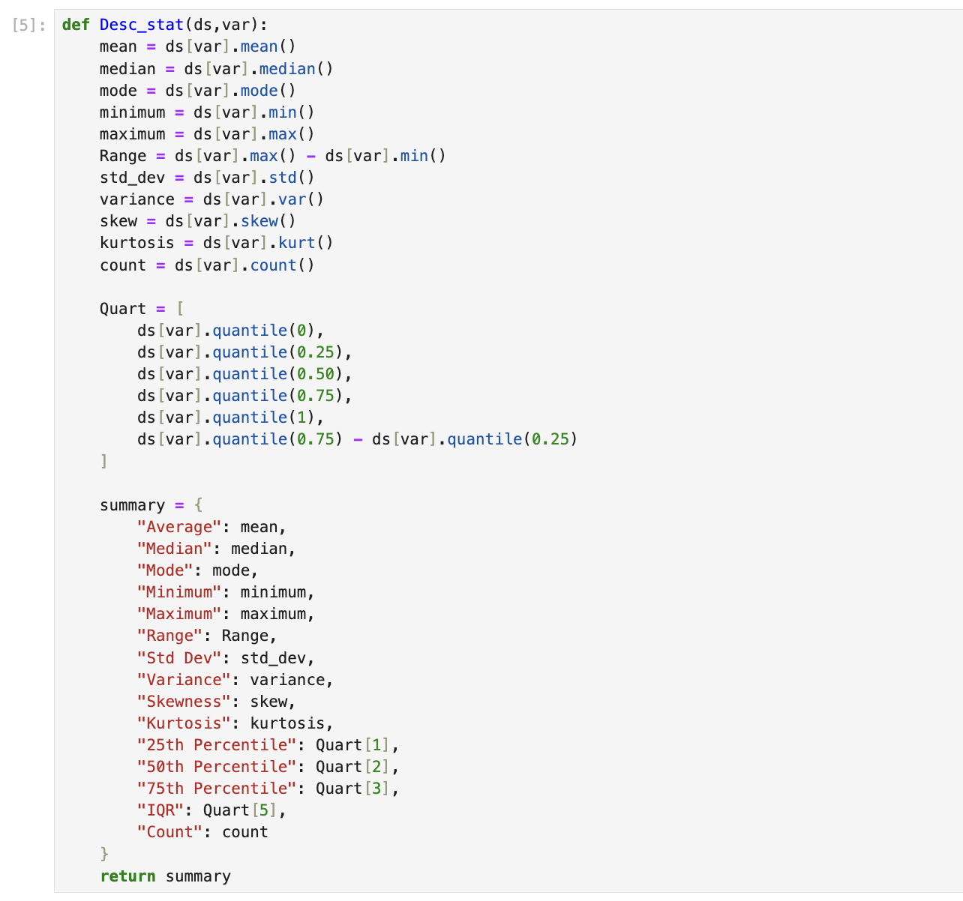

Random Sampling (1 point)

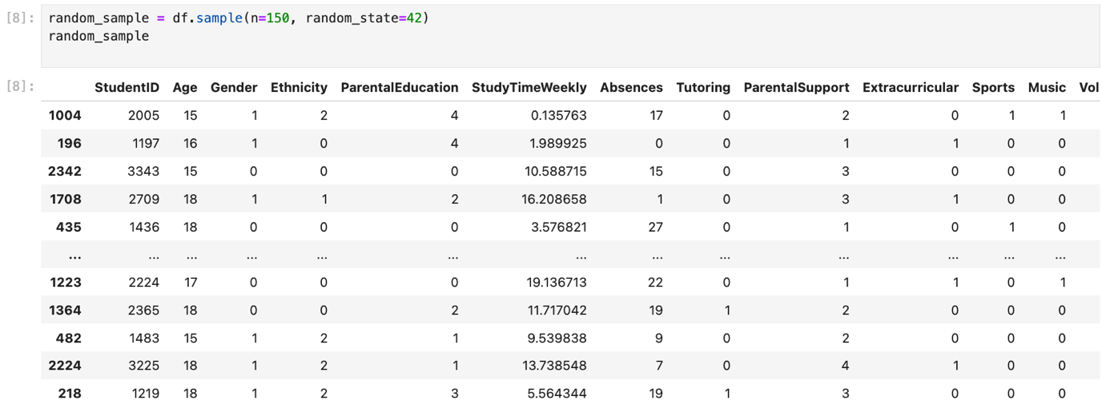

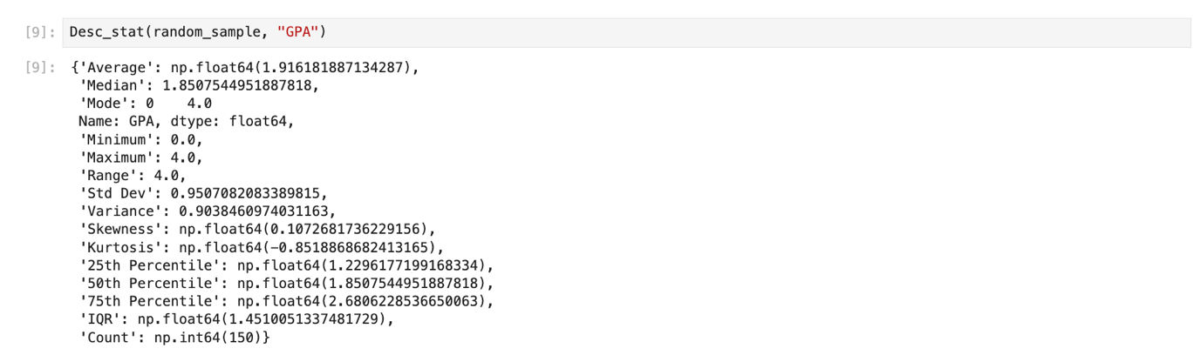
The random sample consists of 150 students. The mean GPA is approximately 1.92, and the median is about 1.85. This indicates that the average academic performance of students in the sample is moderate. The minimum GPA is 0.0, and the maximum is 4.0, indicating a wide range of performance levels.
The standard deviation is approximately 0.95, which suggests a moderate spread around the mean. The skewness value is close to zero (0.11), indicating that the distribution is approximately symmetric. Overall, the random sample provides a balanced representation of student performance.

Systematic Sampling (1 point)

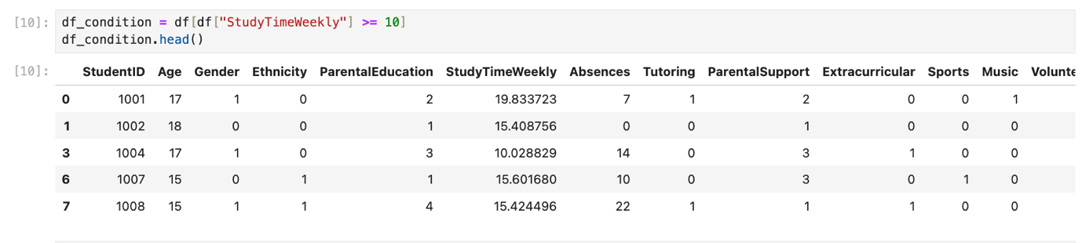

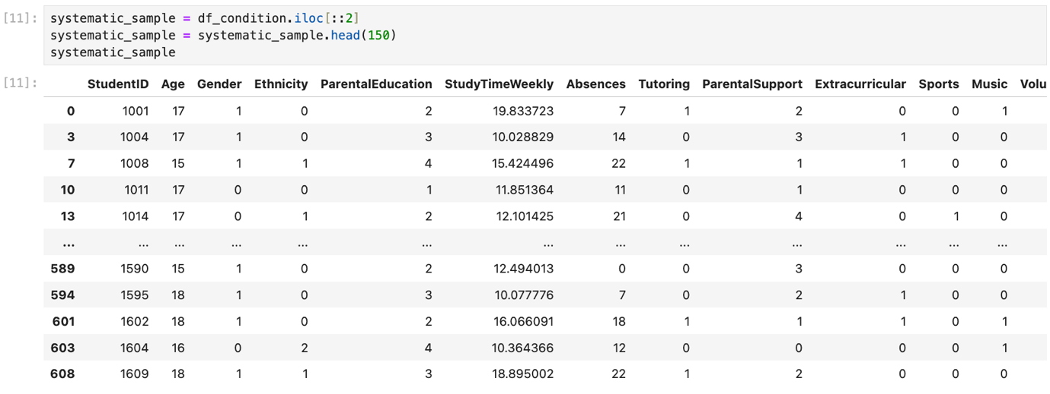
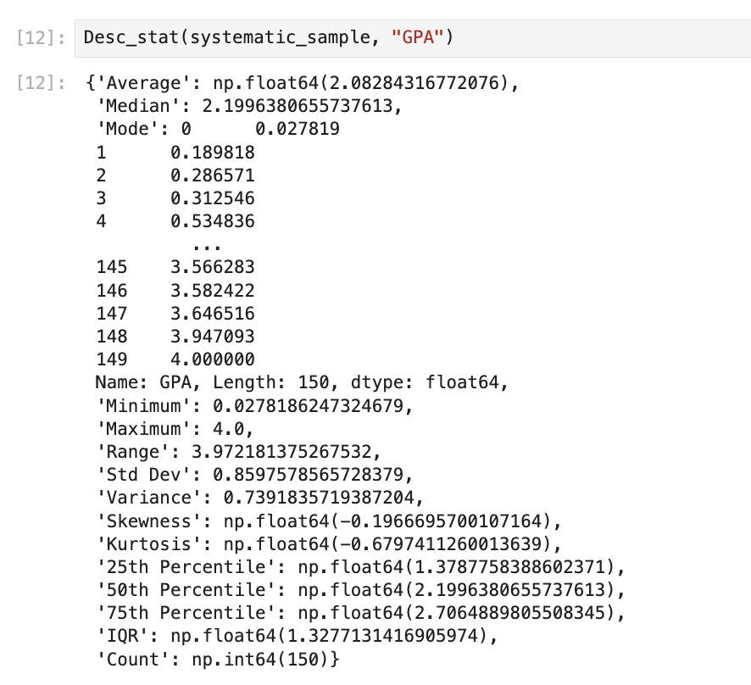

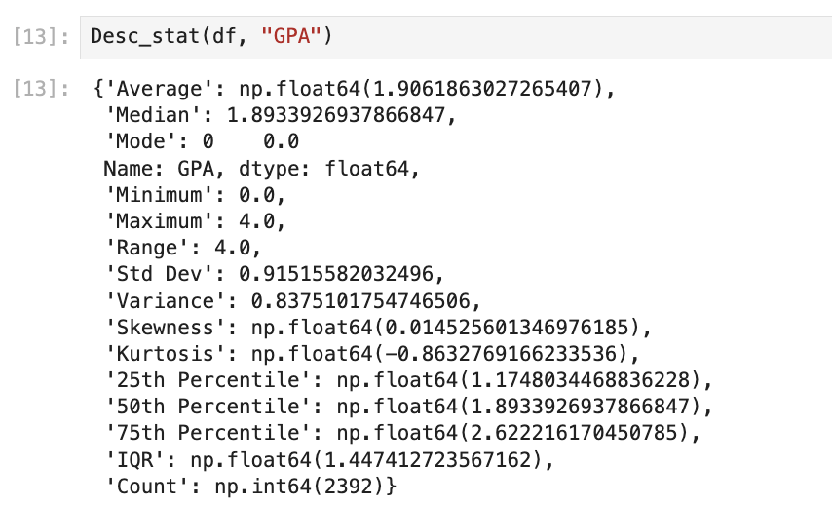
The dataset includes 2392 students. The average GPA is about 1.91, and the median is 1.89. This shows that the overall student performance is moderate.
The minimum GPA is 0.0 and the maximum is 4.0, which means there is a big difference between low and high-performing students.The standard deviation is about 0.92, so the GPA values are spread around the mean at a moderate level.The skewness value is very close to zero (0.015), which means the distribution is almost symmetric.the GPA values are balanced and not strongly skewed.

Descriptive Statistical Report (1 point)

The full dataset includes 2392 students. The mean GPA is approximately 1.91, and the median is about 1.89, which indicates moderate academic performance. The minimum GPA is 0.0, and the maximum is 4.0, showing a wide range of student performance.
The standard deviation is approximately 0.92, suggesting a moderate spread of GPA values around the mean. The skewness value is close to zero (0.015), indicating that the distribution is nearly symmetric. Overall, the GPA distribution appears balanced and centered around the mean.

Visualisation through Various Charts (2 points)
In this section, the dependent variable (GPA) is visualized using different types of charts to better understand its distribution and relationship with other variables. The graphs help identify patterns, trends, spread, and possible correlations.
Scatter Plot

A scatter plot is used to examine the relationship between StudyTimeWeekly and GPA.

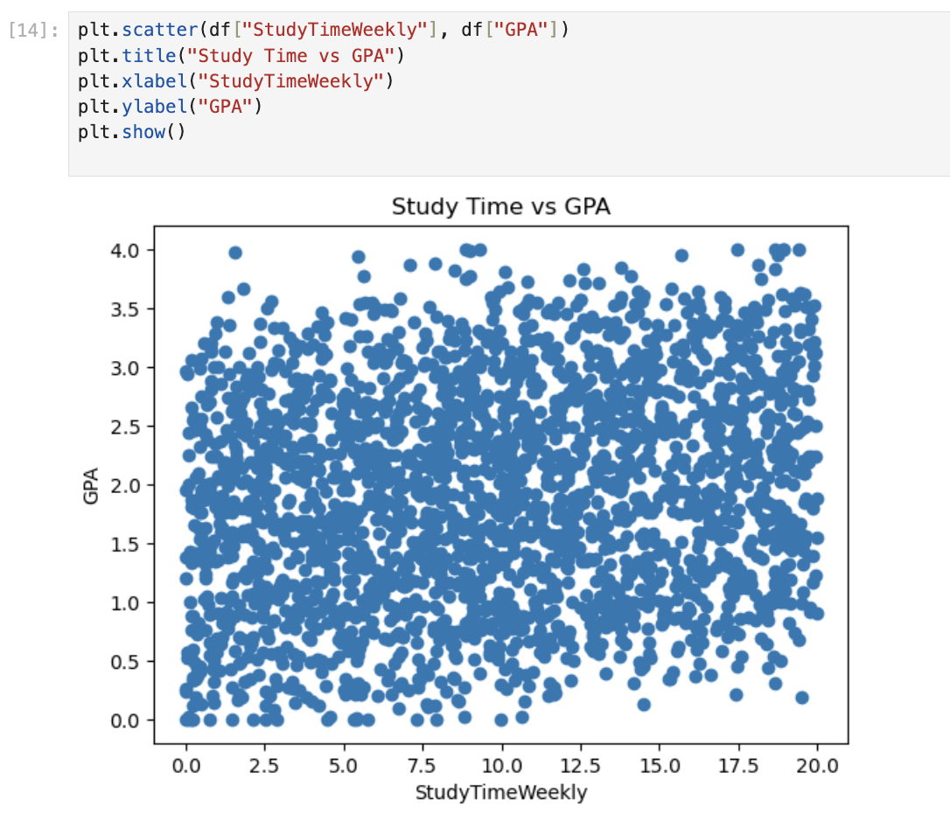
The scatter plot shows a weak upward trend between StudyTimeWeekly and GPA. This means that students who study more tend to have slightly higher GPAs. However, the relationship is not strong, which supports the correlation test results. The points are widely spread, indicating that other factors may also affect GPA.

Box Plot
A box plot is used to analyze the distribution, median, quartiles, and possible outliers of GPA.
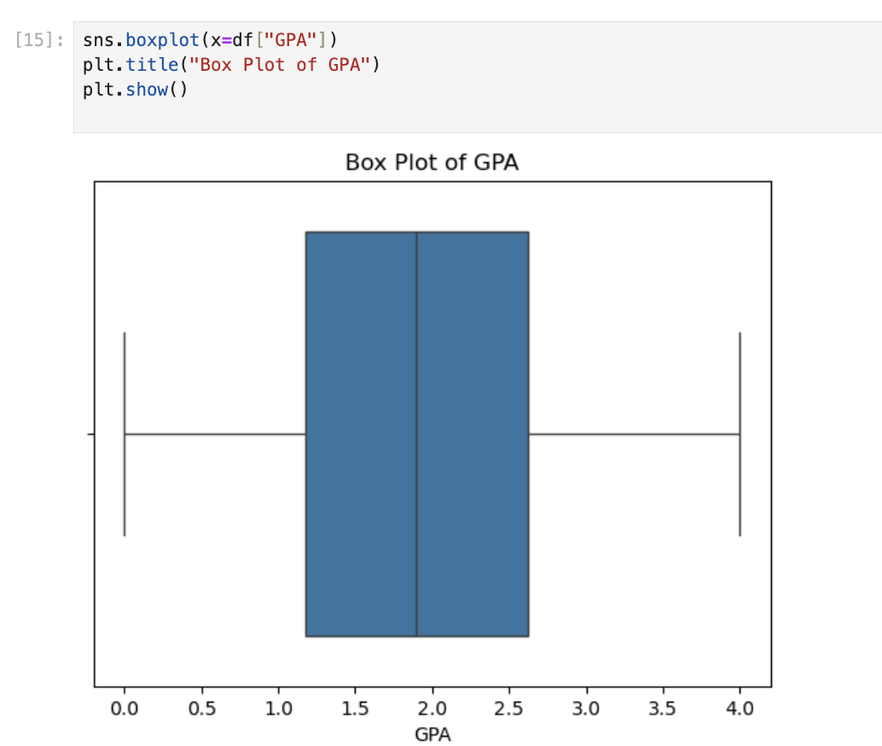

Histogram

A histogram is used to examine the frequency distribution of GPA and observe its shape.

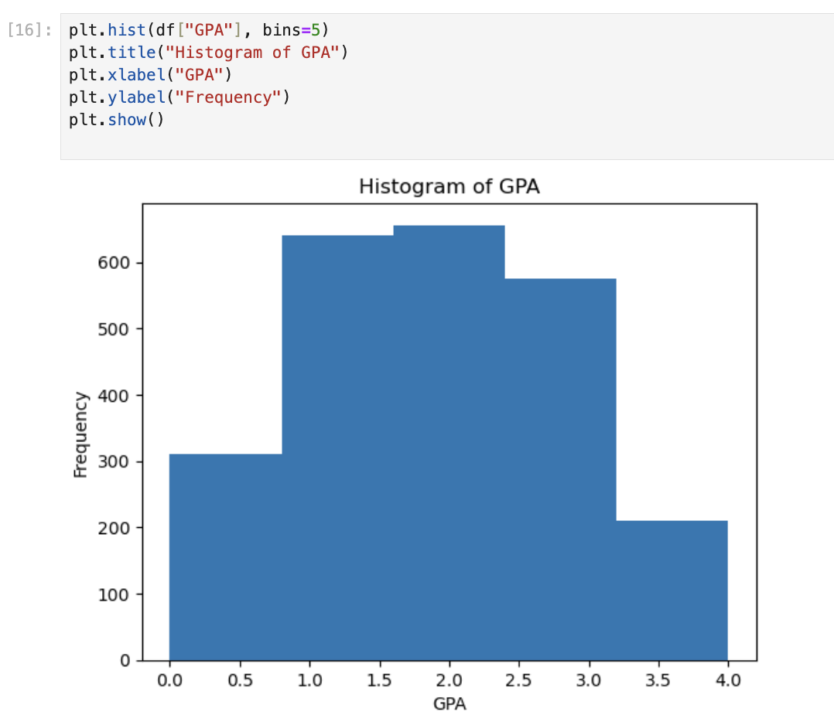

Heatmap

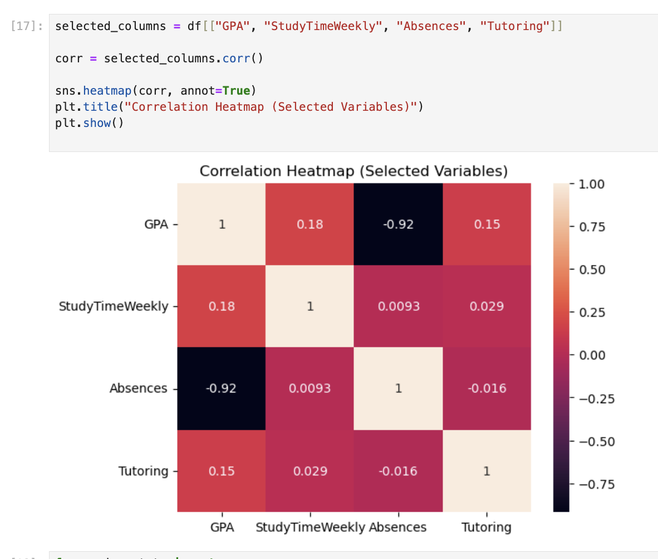

The heatmap shows a weak positive relationship between StudyTimeWeekly and GPA, and a stronger negative relationship between Absences and GPA. This means that higher absences are associated with lower GPA. These results support the correlation analysis performed earlier.

Hypothesis Test (1 point)

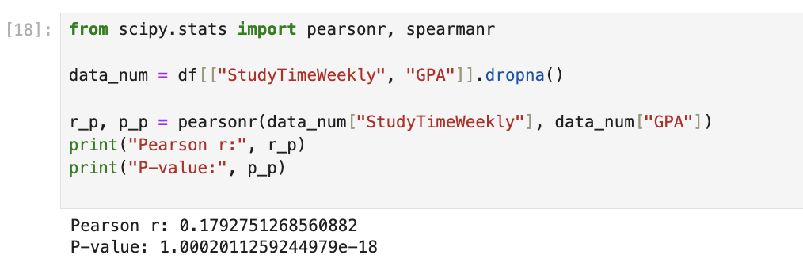

The Pearson correlation coefficient is approximately 0.18, which indicates a weak positive relationship between StudyTimeWeekly and GPA. The p-value is very small (less than 0.05), so we reject the null hypothesis. This means the relationship is statistically significant. However, the strength of the relationship is weak, which suggests that study time has only a small effect on GPA.
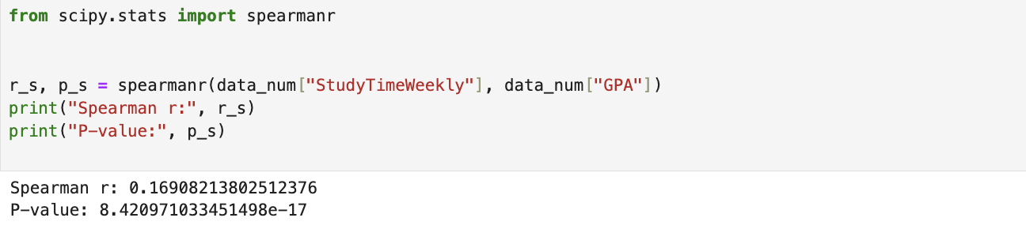
The Spearman correlation coefficient is approximately 0.17, which also indicates a weak positive relationship between StudyTimeWeekly and GPA. Since the p-value is less than 0.05, we reject the null hypothesis. This confirms that there is a statistically significant relationship between the variables, even though the strength of the relationship remains weak.

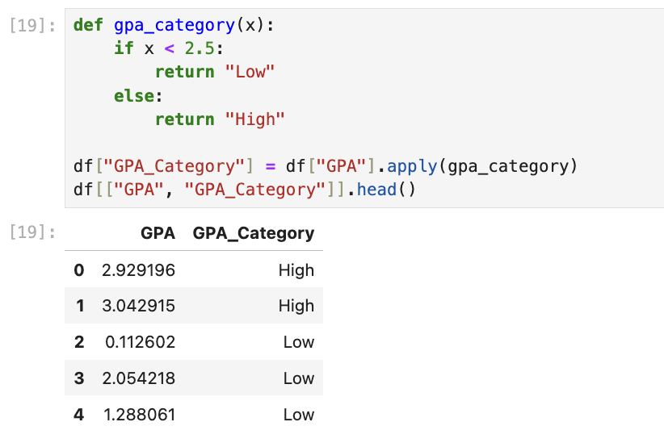

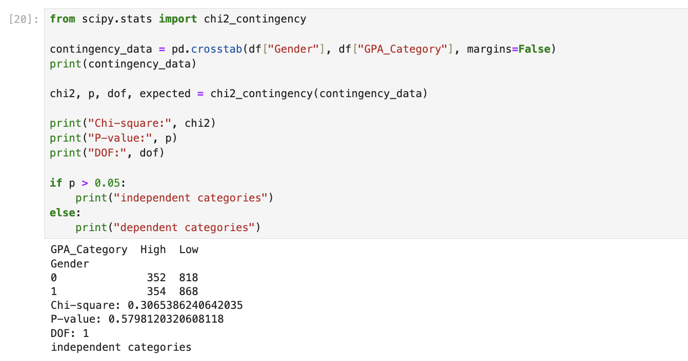
The chi-square test resulted in a p-value greater than 0.05. Therefore, we fail to reject the null hypothesis. This means that Gender and GPA category are independent. There is no significant relationship between gender and academic performance in this dataset.

One Sample T-test (2 points)
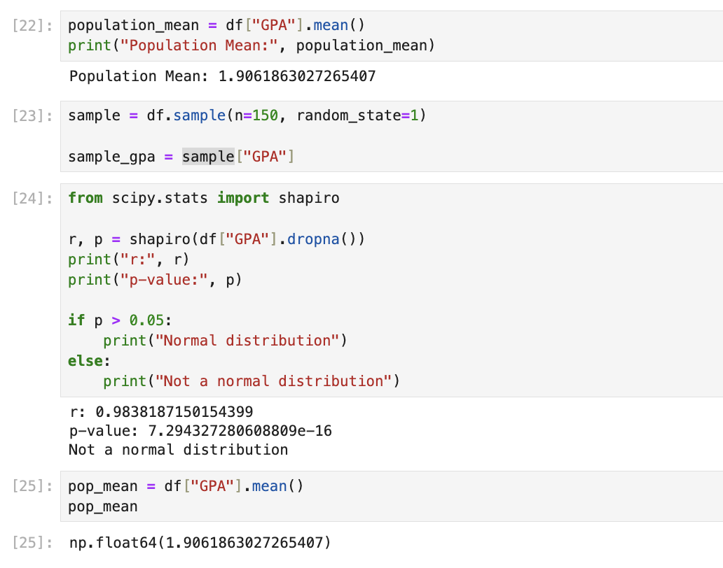
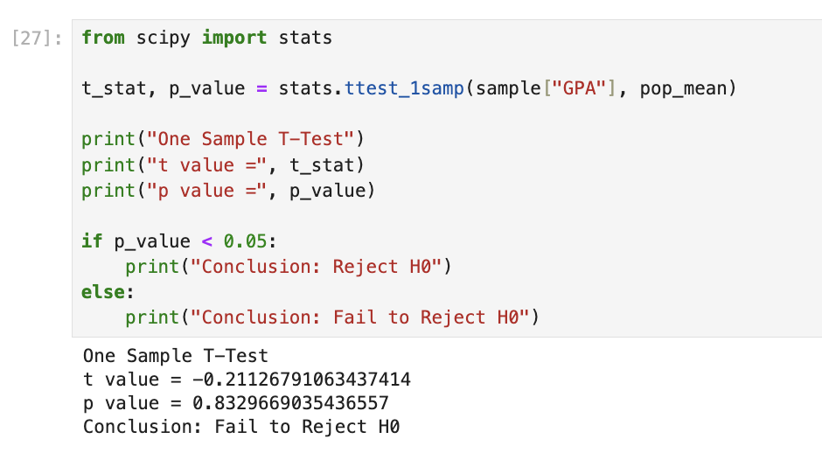

The Shapiro test shows that the data is not normally distributed because the p-value is less than 0.05. This means we reject the null hypothesis of normality. However, since the sample size is large n = 150 , the one-sample t-test can still be applied based on the Central Limit Theorem.

